No. of Pages | 3
No. of Questions | 4

Department of Computer Science and Engineering
FINAL EXAMINATION FALL 2011

CSE490: WAN Routing and Technologies
Total Marks:60 Time Allowed: 1 Hour

- Answer ALL FOUR (4) questions.
- Figure in bracket [] next to each question indicates marks for that question.

Question No. 1

- What are the different ways that you can access a switch to configure it? [3 marks]
- Why do network administrators recommend changing the management vlan from VLAN1 to another vlan number? What kind of traffic flows through the management vlan, give specific examples? [4 marks]
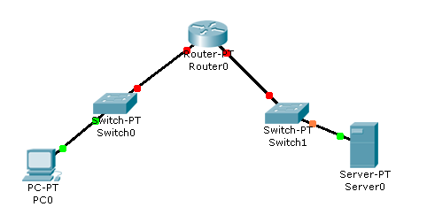
Figure No. 1
- What are the different types of delay that occurs in a switched network, shown in the above figure no.1? [4 marks]
- You shall be able to solve or lessen some problems in a switched network if you enable port security, what are they? Name them and describe one briefly. [4 marks]

Question No. 2

SW1#sh vtp status
VTP Version : 2
Configuration Revision : 10
Maximum VLANs supported locally : 64
Number of existing VLANs : 7
VTP Operating Mode : Server
VTP Domain Name : Bracu
VTP Pruning Mode : Disabled

Figure No. 2

- Refer to the commands in figure no.2 above, In switch SW1 new VLANs 10 and 20 are included by the network administrator. Previous VLAN 30 is renamed to VLAN 50. The network administrator issues the “show VTP status” command again. Will there be any changes in the output? If yes, what are they? [4 marks]

When you add a new switch to an existing network, what steps should you take to ensure that new switch will exchange VTP packets with the older switches? [3 marks]
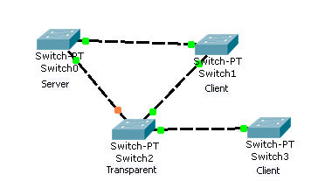
Figure No. 3

- Refer to the figure no. 3 above; the network administrator has just added VLAN 20 in Switch0 and VLAN 60 in Switch 2. How are these additions different? [4 marks]
- Which advertisements does a server switch send and why? [4 marks]

Question No. 3

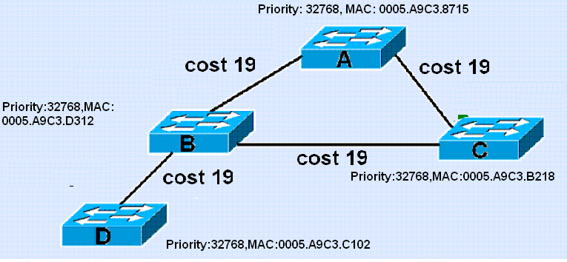
Figure No. 4

- Refer to the above switched network in figure no. 4, after running STP indicate which switch is chosen as the root bridge and which ports are root ports, designated ports and blocked ports? How was the blocked port chosen, explain. [5 marks]
- If a host X connected at switch D, sends a unicast frame to another host Y connected at switch A, and STP is disabled, what will happen? [4 marks]
- If a switch has two ports with the same cost route to the root bridge, which of these ports will become the root port? [3 marks]
- Among the five port states, which of these states are temporary and are not seen once the network has converged, also state the functions of the ports when they are in these temporary states? [3 marks]

Question No. 4

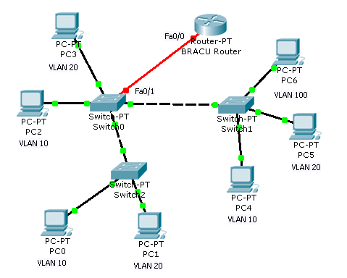
Figure No. 5

- When you add a router to allow inter vlan communication, what are the steps to be taken at the BRACU Router and the Switch 0 shown in figure no. 5. You can write commands or narrate the steps to be taken. [5 marks]
- An organization has three floors of office space in a building. Each floor has PCs belonging to four different VLANs. The staffs of this organization are very mobile, they move a lot from floor to floor. Which method of VLAN assignment in switches will be more efficient here, static or dynamic? Why? [4 marks]
- What is the effect of the command “SW1(config)#delete flash:vlan.dat”? What is flash? [3 marks]
- Why would ‘Router on a Stick’ create a bottle neck? [3 marks]

THE END

